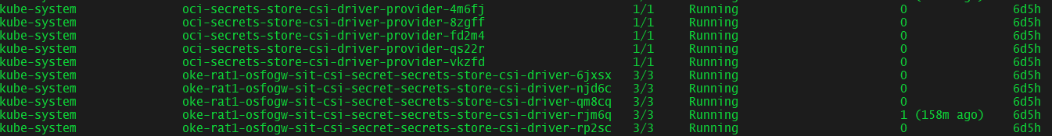

OCI Vault

<https://console.eu-dcc-milan-1.oraclecloud14.com/>

login to vf account DRCCVFDE

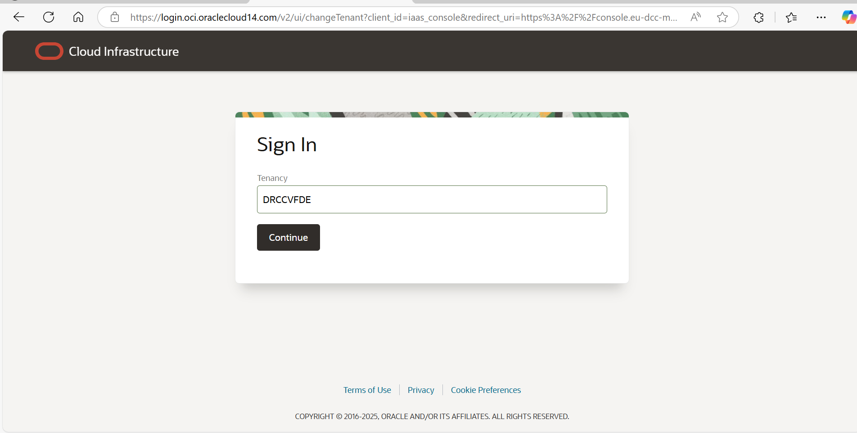

Select to azure AD

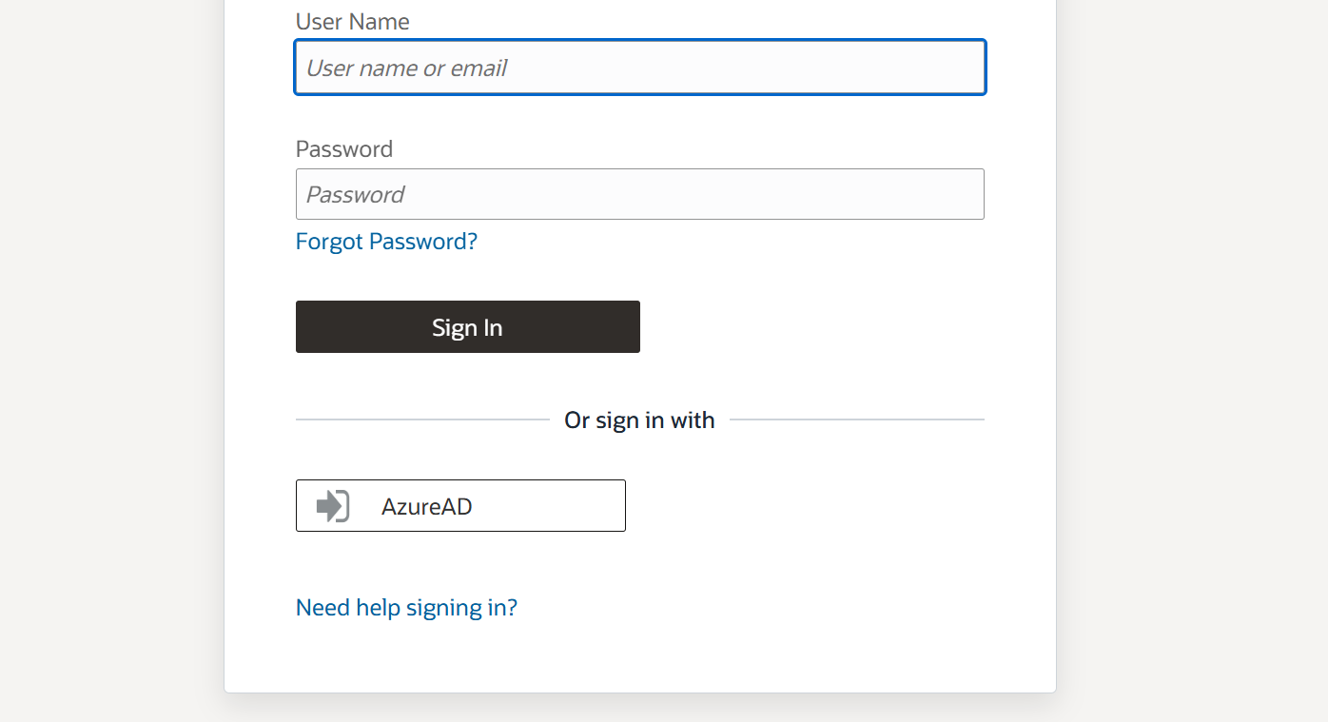

Change VF dedicated region to rat 1 and search vault in search bar and select vault services

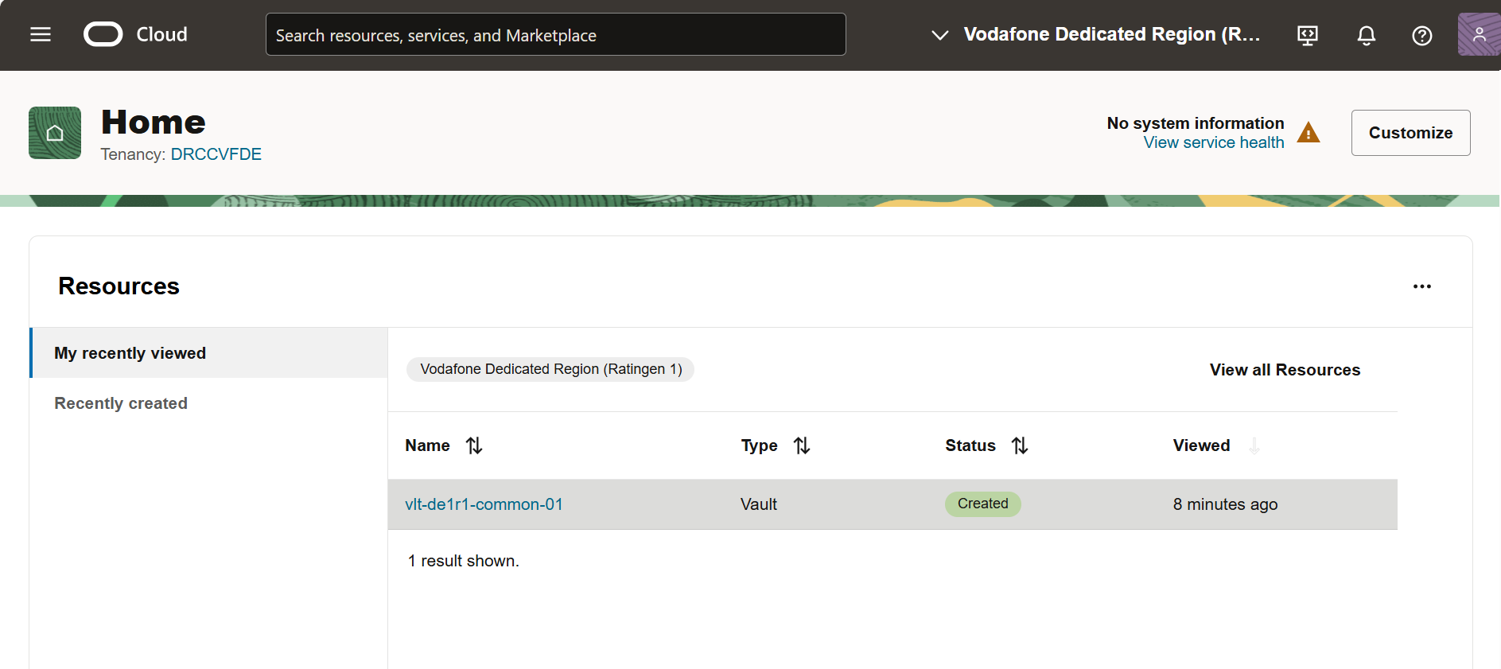

It will redirect you to this

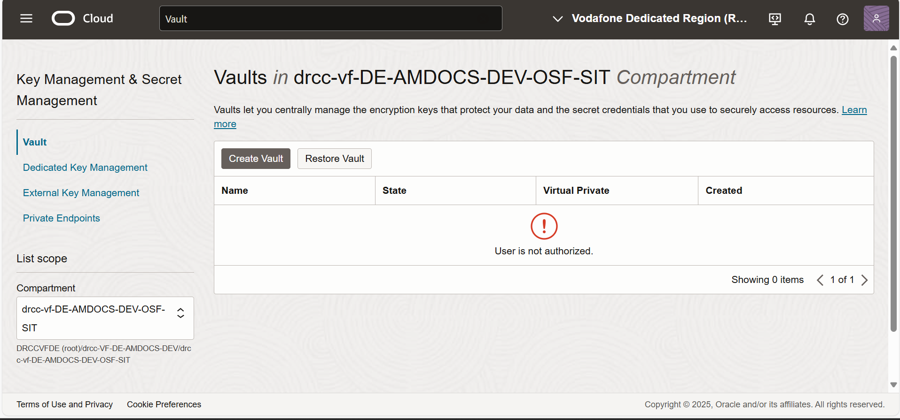

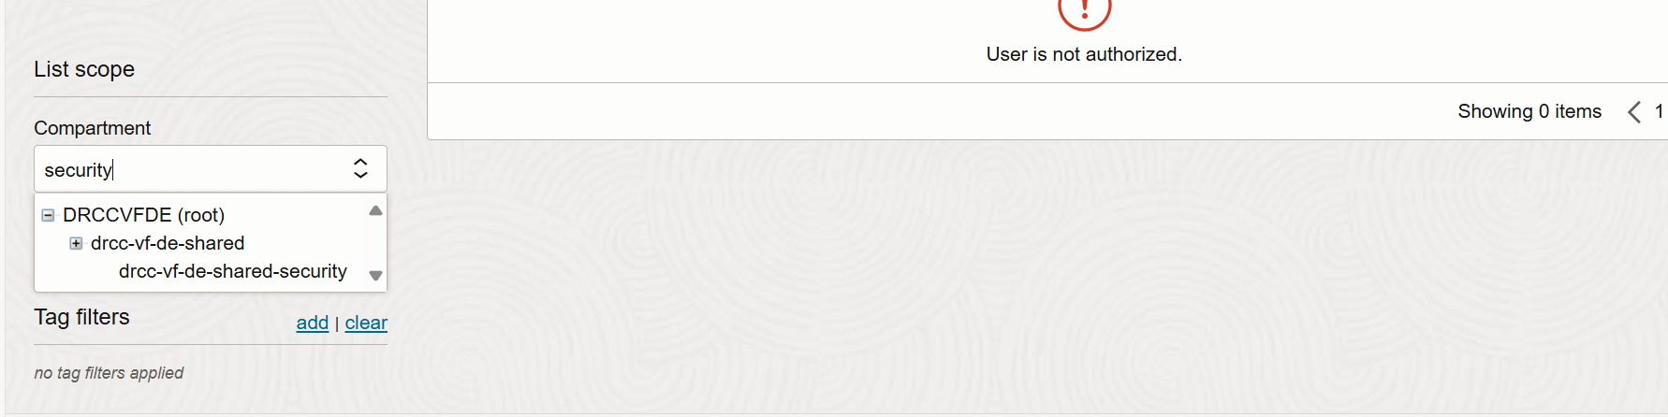

And select last option with security.

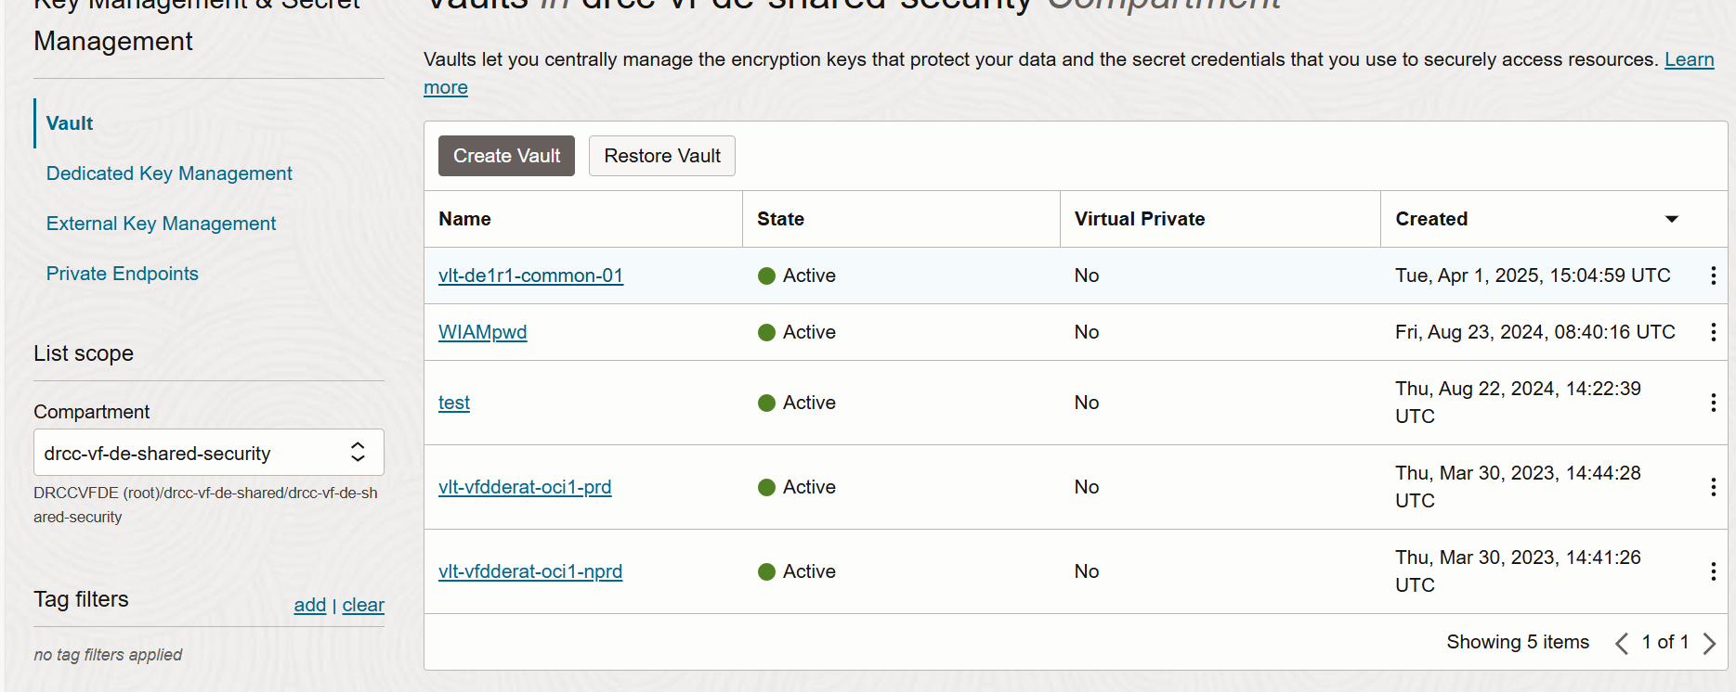

Click on common one

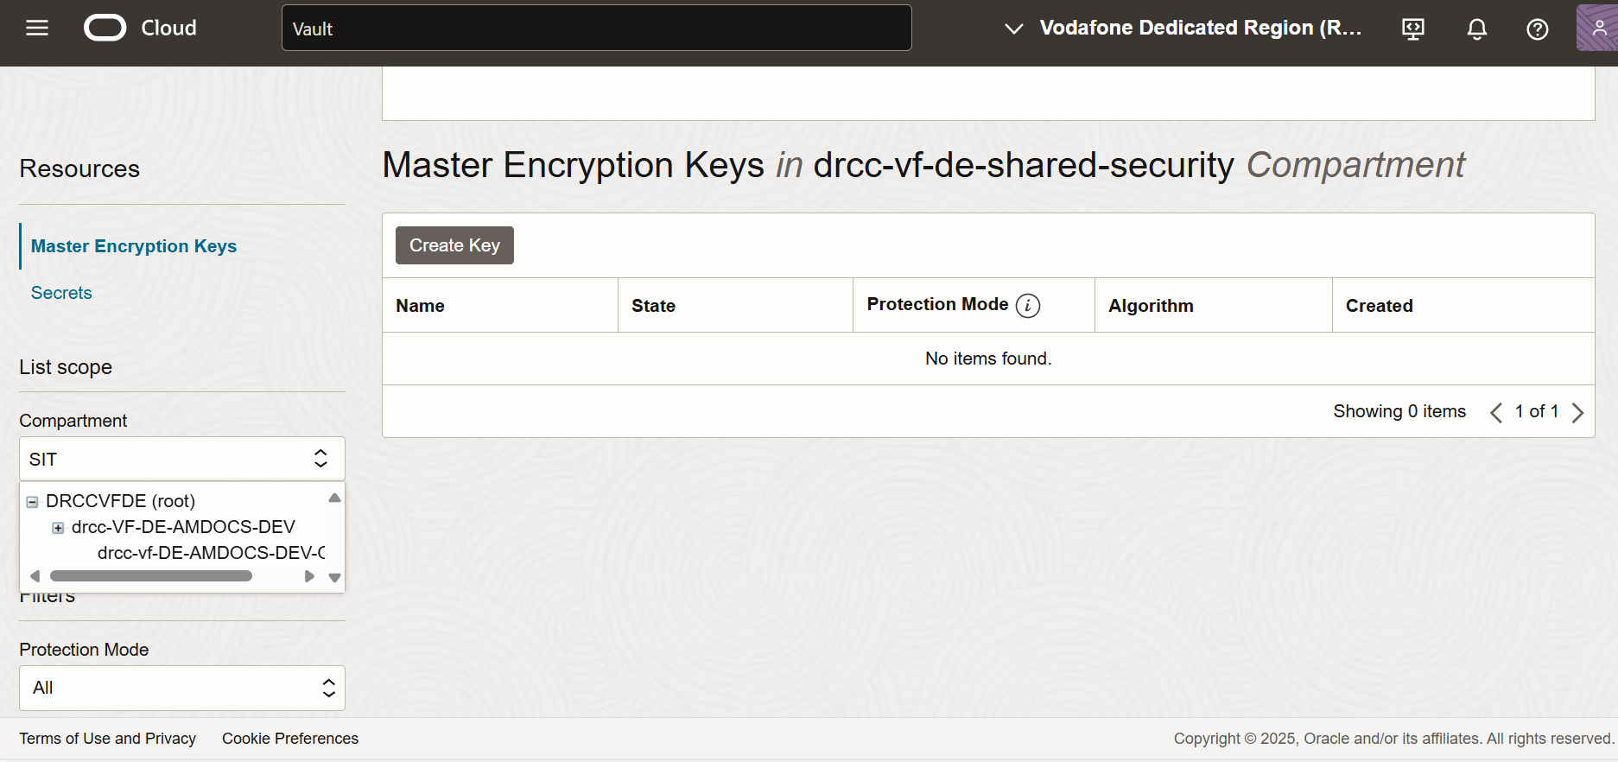

Then select compartment again and type sit (select last option)

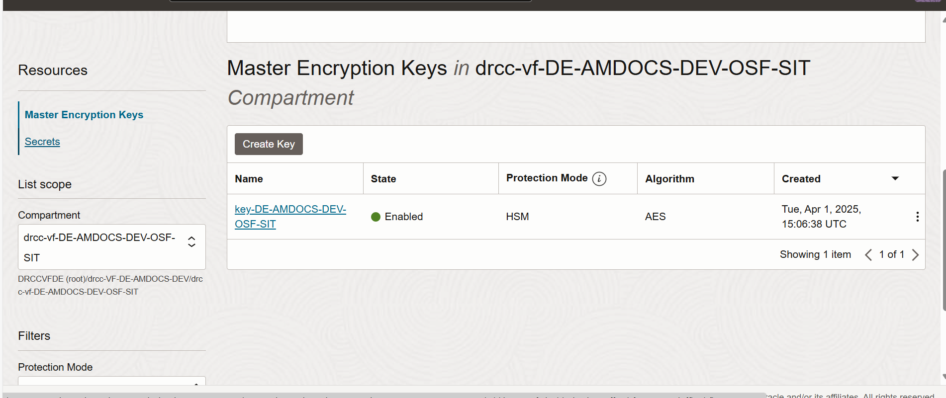

Click on secret—under resources

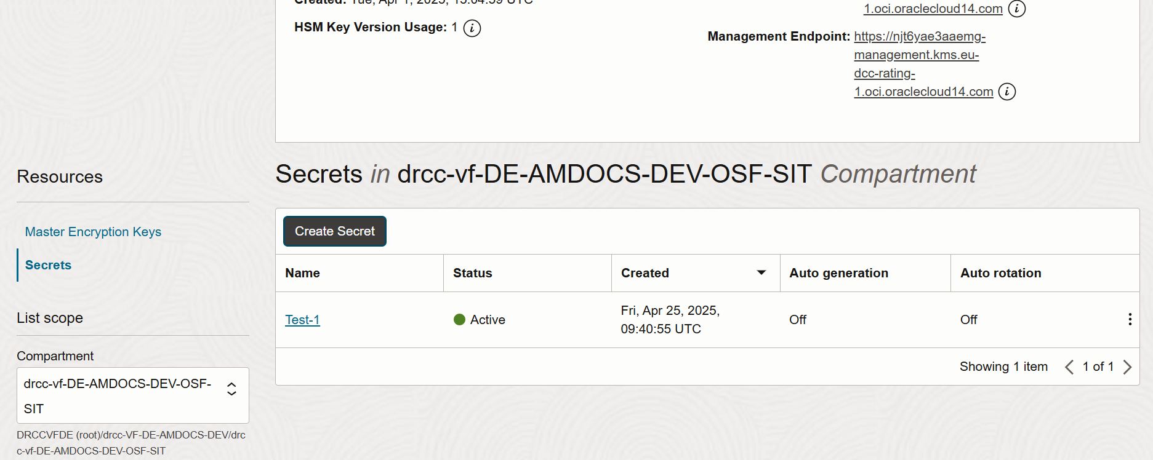

Then click on create secret

Hello Anand Sinha

You have to create **secretProviderClass** and mount that in manifest in order to use

* Create 'secretproviderclass' kubernetes object, sample manifest file

apiVersion: [secrets-store.csi.x-k8s.io/v1](http://secrets-store.csi.x-k8s.io/v1)  
kind: SecretProviderClass  
metadata:  
  name: my-test-spc  
spec:  
  provider: oci   
  parameters: # provider-specific parameters  
    secrets: |  
      - name: secret1              # Name of the secret in vault  
        stage: 1         # Version of the secret  
        fileName: app1-db-password # Secret will be mounted with this name instead of secret name  
    authType: instance             # possible values are: user, instance  
    vaultId: ocid1.vault.oc1..aaaaaaaaaaaaaaaaaaaaaaaaaaaaaaaaaaaaaaaaaaaaaaaaaaaaaaaaaaaa

* Deploy the workload by defining the volume specifying secret store driver ([secrets-store.csi.k8s.io](http://secrets-store.csi.k8s.io/)) and configure secretProviderClass property referring to the SPC name as shown below

volumes:  
- name: secrets-store-inline  
  csi:  
    driver: [secrets-store.csi.k8s.io](http://secrets-store.csi.k8s.io/)  
    readOnly: true  
    volumeAttributes:  
      secretProviderClass: my-test-spc

* Mount volume on to container

volumeMounts:  
   - name: secrets-store-inline  
     mountPath: '/mnt/secrets-store'

* Deploy the application/deployment/pod
* Verify the deployment is running and secret is created and mounted on the pod.

*kubectl get secret* → list the secrets